The second online discussion focuses on the question of " Cuts to Reshape Government". Please be aware of the policies for online discussions from the syllabus: Student contributions will be assessed based on their ability to address the issues presented using concepts and evidence from the course that engages fellow students in a thoughtful progression of ideas. Each discussion forum will be available immediately after classes week 6 and close at noon week 7 before classes. During the week-long discussion, students should expect to contribute to the discussion on at least three different days including one posting of at least 200 words. All quoted materials must follow proper citation format.

**Trump Seeks $3.6 Trillion in Cuts to Reshape Government**

*by*

*Justin Sink*

*and*

*Erik Wasson*

May 22, 2017, 6:00 PM PDT May 22, 2017, 6:52 PM PDT

* Budget plans faces rejection by lawmakers from both parties
* Cuts would carve through range of federal safety-net programs

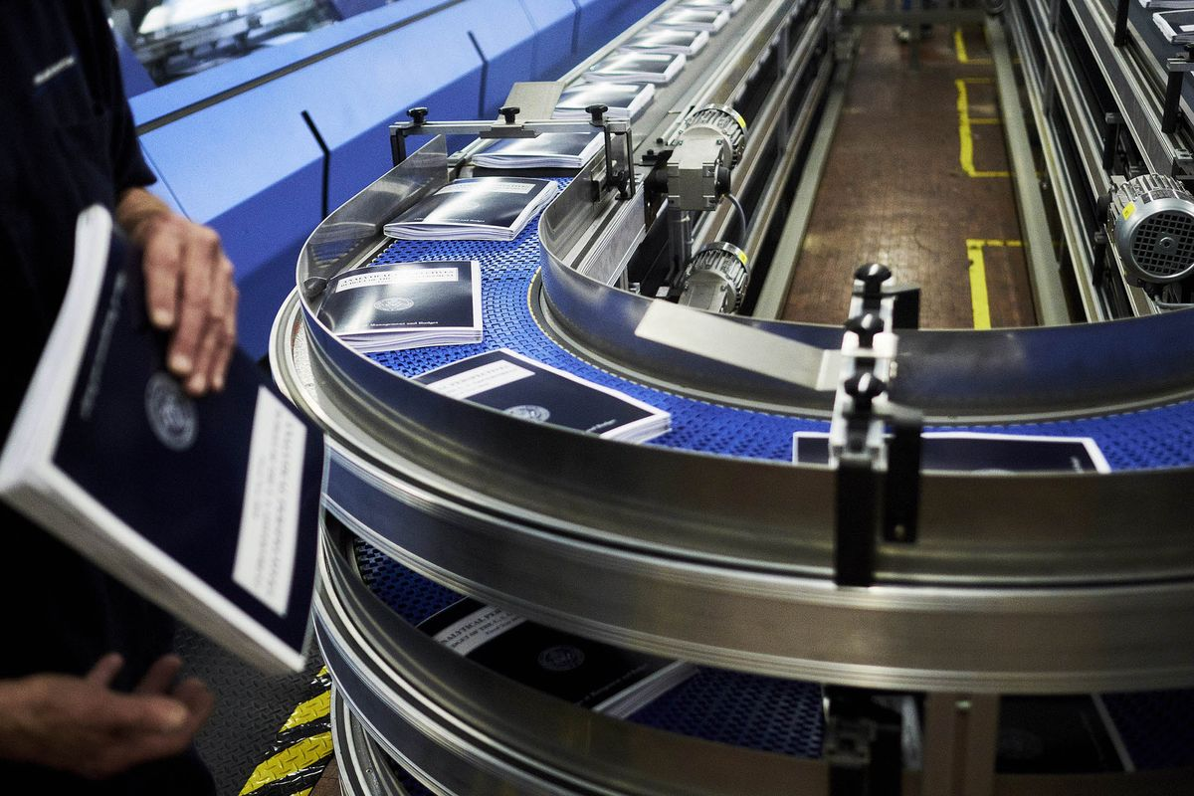Copies of the fiscal year 2018 budget move along a conveyor belt during the binding process inside the Government Publishing Office production facility in Washington, D.C.

Photographer: T.J. Kirkpatrick/Bloomberg

President Donald Trump would dramatically reduce the U.S. government’s role in society with $3.6 trillion in spending cuts over the next 10 years in a budget plan that shrinks the safety net for the poor, recent college graduates and farmers.

Trump’s proposal, to be released Tuesday, claims to balance the budget within a decade. But it relies on a tax plan for which the administration has provided precious little detail, the elimination of programs backed by many Republican lawmakers, and heavy use of accounting gimmicks.

Trump’s fiscal 2018 budget proposal has already been declared dead on arrival by many of his Republican allies in Congress. The plan would slash Medicaid payments, increase monthly student loan payments and cut food stamps and agricultural subsidies, each backed by powerful constituencies. The administration is unbowed.

"We’re no longer going to measure compassion by the number of programs or the number of people on those programs," White House budget director Mick Mulvaney said. "We’re going to measure compassion and success by the number of people we help get off those programs and back in charge of their own lives."

Senate Republican Leader Mitch McConnell has already said he expects the Republican-led Congress to largely ignore the proposal, saying in an interview last week with Bloomberg News that early versions reflected priorities that "aren’t necessarily ours."

**Campaign Promises**

The president’s proposal would fulfill his campaign promise of leaving Social Security retirement benefits and Medicare untouched while increasing national security spending. He’s also proposing severe cuts to foreign aid and tighter eligibility for tax cuts that benefit the working poor. He also seeks cuts in food stamps and disability insurance.

The plan calls for some new domestic spending, including $25 billion over 10 years for nationwide paid parental leave -- a cause championed by First Daughter Ivanka Trump -- and an expansion of the Pell Grant program for low-income students. The Department of Homeland Security’s budget would increase $3 billion versus the final full year of President Barack Obama’s term, while the Pentagon’s budget would see a $6 billion increase over that same time.

The sheer ambition of the president’s plan, which would cut domestic agencies by 10 percent in 2018 and by 40 percent in 2027, make the budget even less likely to gain traction on Capitol Hill, where lawmakers regularly flout the annual blueprint offered by the executive branch. But lawmakers are also likely to view some of the administration’s accounting gimmicks with extreme skepticism.

**Economic Growth**

The budget predicts a sweeping tax overhaul package that would strengthen economic growth while providing few details of how the tax code would change. The one thing the administration has said is people and businesses will pay less; the budget asserts the amount of revenue collected won’t drop.

Neither of the White House’s assertions -- that Trump’s tax plan would be both revenue neutral and fuel budget coffers by $2 trillion to $2.6 trillion through economic growth -- are realistic, said Maya MacGuineas, president of the bipartisan Committee for a Responsible Federal Budget.

She called the administration’s projections of three percent annual growth "really not possible -- they have impossible assumptions of no changes in revenue and tax cuts." She added that to see three or four percent growth "is nearly unprecedented. You’d need productivity growth at a level you’ve never seen."

The scant detail in Trump’s tax proposal was likely to hinder tax reform, she said. "They rolled out all the goodies but none of the offsets that would be necessary," MacGuineas said. "I’m not a fan of surprises, and you have to set realistic expectations, because there are real trade-offs and choices."

The independent Tax Policy Center estimated that Trump’s campaign tax plan would add $7.2 trillion to the deficit. Economic growth spurred by Trump’s tax and regulation policy would add more than $2 trillion in tax revenue, according to the budget documents.

**Accounting Gimmicks**

The budget also makes use of several other classic accounting gimmicks. It assumes that the wars in Afghanistan and the Middle East will cause future Congresses to allocate $593 billion in extra war funding that won’t be needed and then claims to save that amount by not spending it.

The Trump budget also assumes a $35 billion savings from changes to financial services industry regulations and a repeal of the Dodd-Frank law’s orderly liquidation authority, under which financial regulators are empowered to untangle and wind down the biggest banks in a crisis. The nonpartisan Congressional Budget Office projected savings of $14.5 billion over a decade from eliminating the authority.

Trump has promised a wall on the southern U.S. border that Mexico will eventually pay for, and the budget includes $2.6 billion in 2018 – $1.6 billion for “new and replacement border wall’’ in certain locations and about $1 billion for other items including aircraft, equipment and surveillance technology to deter illegal activity. Trump estimates the wall will cost $8 billion to $12 billion, but most experts say it will likely be more expensive.

While Trump is proposing to increase the defense budget, the push for more high-priced weapons will wait another year.

The Trump budget requests 70 Lockheed Martin Corp. F-35s and 14 Boeing Co. F/A-18E/F fighters -- the same quantities anticipated by Obama’s administration for fiscal 2018. Similarly, the administration is requesting eight new Navy ships, the number proposed by Obama. With Trump pledging to increase the Navy fleet to 350 ships from 275 that can be deployed today, the Navy has said it will need to request 12 new vessels in fiscal 2018 to start the acceleration.

**Safety Net**

But while defense spending is set to see a boost, social safety net programs are in the president’s crosshairs. Medicaid cuts of $610 billion would come alongside $250 billion savings -- partly fueled by limiting expanded Medicaid -- from repealing Obamacare. Food stamps would be cut by $193 billion.

Federal workers would see much less generous retirement benefits under the budget. Eliminating cost-of-living adjustments for retirees would save $42 billion while increasing required employee retirement contributions would save $72 billion. And the budget would save $72 billion through cuts to Social Security Disability Insurance.

The administration has pitched its changes to student loan programs as beneficial to students. The budget would create a single repayment plan that would cap monthly payments at 12.5 percent of discretionary income, an increase from the 10 percent cap under some existing payment plans. But students would only need to repay their loans for 15 years, rather than 20, with the remainder wiped out by the federal government. That change would cut the federal subsidy by $76 billion.

https://www.bloomberg.com/politics/articles/2017-05-23/trump-seeks-3-6-trillion-in-spending-cuts-to-reshape-government